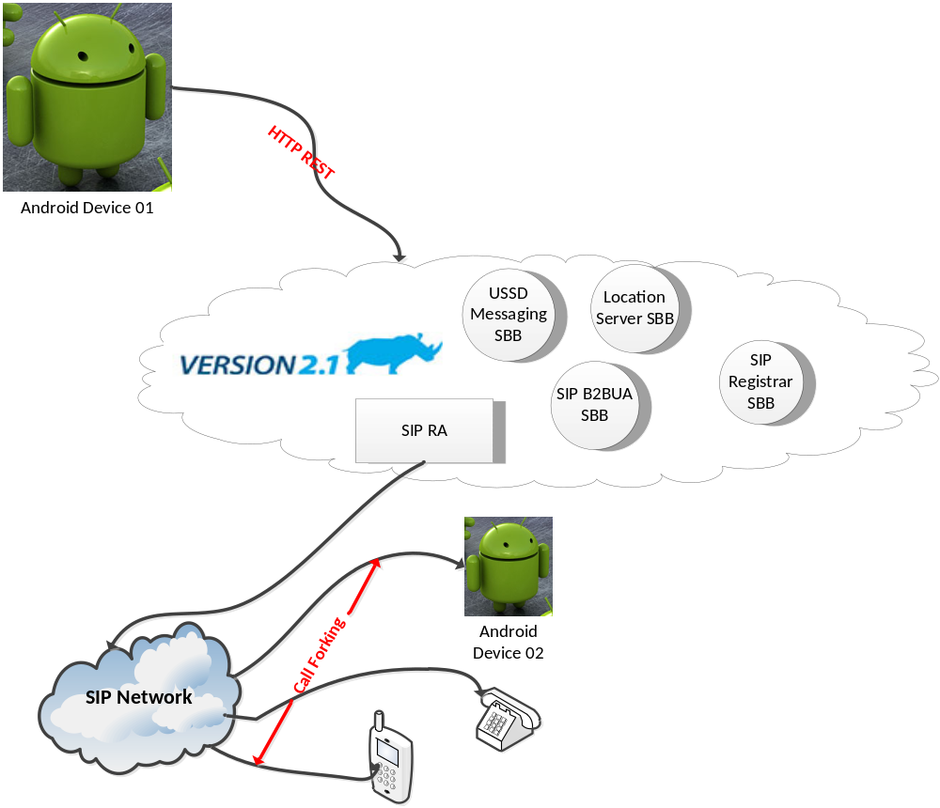
Development Timetable

Phase I: Baseline architecture (one number service)
Task | # of days | Description
SIP client installation and testing and environment set up and preparations | 1 | Installing an open source SIP client on the android devices to act as the main dialler when demonstrating this service.
SIP Registrar SBB | 2 | Developing a SIP registrar SBB to handle the SIP REGISTER requests initiated from the Android SIP clients.
SIP B2BUA SBB | 4 | Developing a SIP B2BUA that handle the call forking, screening and routing of the incoming/outgoing calls as per the preferences set by the users. The SIP B2BUS SBB maintains these users’ preferences in a central database managed and accessed by the same SBB.
Android UI design & development | 4 | Developing the User Interface (UI) using the android SDK that expose the caller/called preferences configurable options to the users.
Android-Rhino REST interface development | 3 | Developing the HTTP REST interface between the Android device and the Rhino Application Server, it is via this interface the users can set their caller/called preferences for the proper handling of the incoming/outgoing calls.
Service Testing | 2 | Testing and demonstrating the whole scenario of the developed service with respect to the set user preferences.
Phase II: Context-Aware features development
Task | # of days | Description
Location Server SBB | 2 | Developing an SBB that acts as location server that responds to MLP requests initiated by other location client SBBs.
MLP-RA development | 5 | Development of an MLP-RA that facilitate the MLP message exchange between the MLP location servers and any other location client SBBs
Android-Rhino interface location extension | 3 | Extending the REST interface between the Rhino and the android device to support the location services.
Google Maps addition to the UI | 1 | Integrating Google Maps within the android application UI
Mobile Social Network & Tap 2 Call | 3 | Development the friend’s addition/removal and enabling the context-aware TAP 2 Call feature.
Context-Aware push messages | 3 | Developing a service feature of push commercial messages in regard to the current location of the mobile user.
Phase III: USSD Support features development
Task | # of days | Description
USSD messages addition to the UI | 2 | Adding the required new fields and menus to the UI to support the USSD messaging feature
Android-Rhino interface USSD extension | 2 | Extending the REST interface between the Rhino and the android device to support the USSD message exchanges.
CGIN installation & configurations | 1 | Installing and configuring the CGIN, the RA entities and the TCAP simulator instances so support the USSD messaging service.
Mock USSD Service SBB | 5 | Developing a Mock USSD service that is listening to USSD specific events and responds to the USSD requests initiated by the client software.

